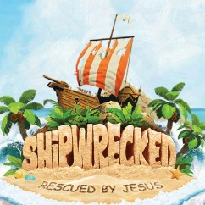
REGISTRATION FORM
(One per child)
50 participants per session $20 per child

Child’s name: _________________________________________________________________________
Child’s age: _______ Last school grade completed: _______ Shirt size: _____________
Which session will your child be attending:
____ 8:30 am - 12:00 pm ____ 1:30 pm – 5:00 pm
Name of parent: _____________________________________________________________________
Contact number: ____________________________________________________________________
Emergency contact name: __________________________________________________________
Emergency contact number: _______________________________________________________
Allergies/Medical Information: ____________________________________________________
Names of person(s) to which the child (children) may be released to each day after VBS
Name: ________________________________________________________________________________
Name; ________________________________________________________________________________
I hereby give permission for photographs and/ or video in which my child appears in to be used by the church in printed and /or electronic media, including the church website.
I agree
I disagree

Payment received:
Date: _____________________ Check ________ Cash_____ Initials_________

